|  |
| --- |
| 新东方在线英语学习 |
| 新概念 1 册 |
| Lesson97-98 |

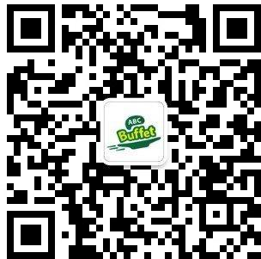

扫一扫。更多有趣的英语资讯。

# Lesson 97 单词讲解

1. leave:

leave-left-left

* 1. 离开

He has left Beijing.

Don’t forget to give me the room key before you leave the hotel.

* 1. 遗留、落

I left my bag on the train.

Please leave the door open.不要关门 客气的说法

1. describe: 描述di si kuai e be

Please describe a person you like best.

3. 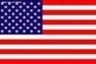 zipper

zip: v. 拉

zip

Please zip your lips. Lai pu si

Please shut up.

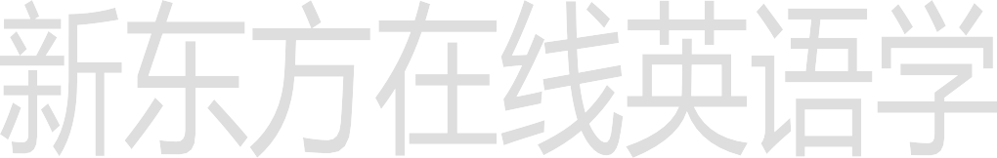

1. label: 标签
2. handle: 提手、把手han dou
3. address: 地址

What’s your address?

Can you please tell me your address?

1. pence: penny 的复数
2. belong: v. 属于不及物动词 要加to
   1. belong-belonged
   2. belong to

Belong to me\ her\ him\ them\ us

That dictionary belongs to me.di ke shen ne rui

Does the house belong to you? What party do you belong to?

# Lesson 97 课文讲解

1. 一个蓝色的小箱子

a small blue case

多个形容词的顺序：

限定描绘大长高，形状年龄和新老，颜色国籍和材料。限定词：the, this, that, my, your, one, two…

描绘：beautiful, cold, pretty, good

形状：round, square(si gui er)…

材料： wooden(wo den), stone(si dou en), leather(lai der )…

限定描绘大长高，形状年龄和新老，颜色国籍和材料。

* 1. 一枚小的圆形英国硬币
  2. 一件崭新而漂亮的意大利黑皮夹克

a beautiful new black Italian leather

* 1. This girl is Linda’s cousin.ka zei en(2005 北京高考卷)

A. pretty Spanish little B. little Spanish pretty

C. pretty little Spanish D. Spanish pretty little

1. … on the train to London.

on: on the train\ bus\ plane

the train to London: 开往伦敦的火车

开往莫斯科的列车：the train to Moscow

从上海飞来的航班：the flight from Shanghai

我把钱包落在了去郑州的火车上。

I left my wallet on the train to Zhengzhou.

1. the other day:

前几天

4 on the handle with my name and address on it.

上面写有我的名字和地址。盒子上有个标签,上面标着价格。



There is a label on the box with the price on it.

T 恤衫上有个标签,上面标着尺码。

There is a label on the T-shirt with the size on it.

他给我一张纸条，上面写着他的电话号码。

He gave me a piece of paper with his phone number on it.

我给他一张卡片，上面写着我的地址。

I gave him a card with my address on it.

他递给了我一本笔记，里面是他的日记。

He passed me a note book with his diary in it.

# Lesson 97 语法讲解

1. 名词性物主代词：

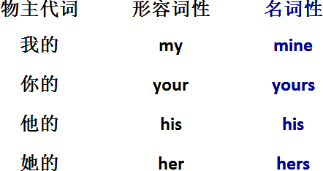形容词性物主代词+n.

名词性物主代词可以作主语、表语、宾语

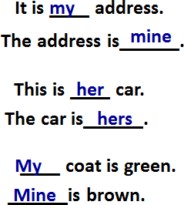

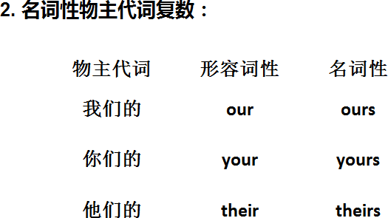

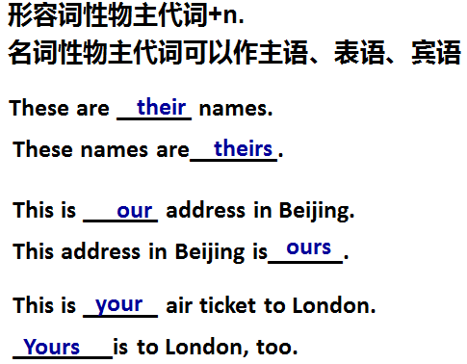

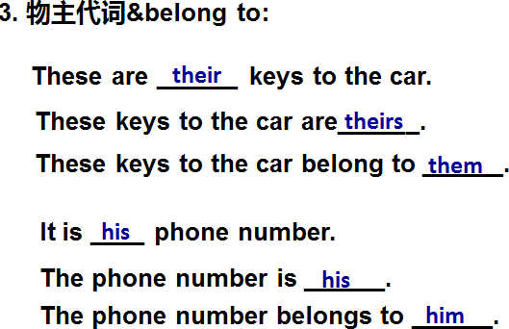

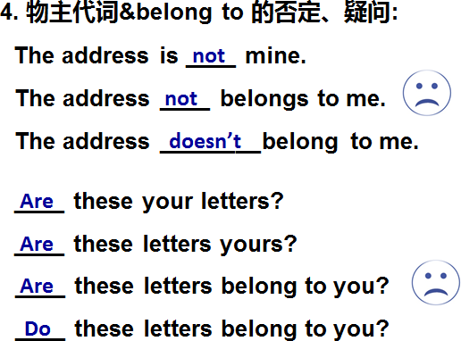

# Lesson 98 单词句型讲解

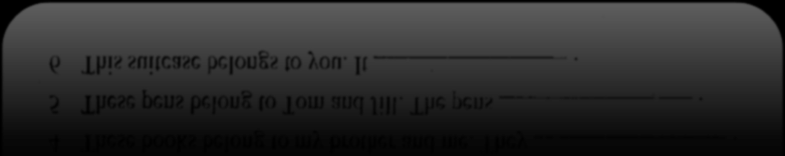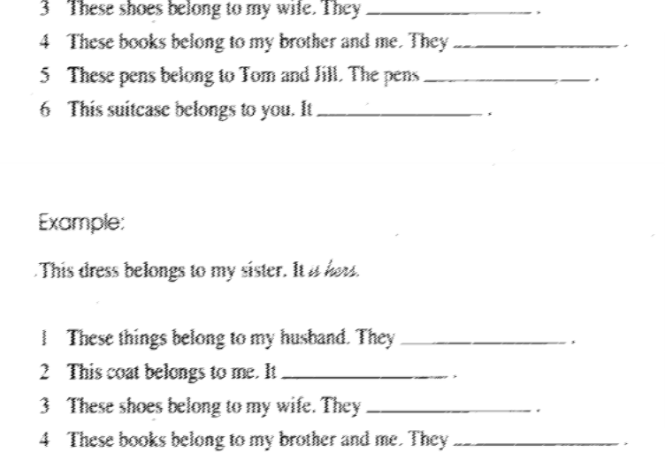

Are these theirs keys? Are these keys theirs?

Do these keys belong to them?

Is this your letter? Is this letter yours?

Does this letter belong to you?

# Lesson 97&98 知识拓展

**美国人常用粗话：**

1. Fuck！
2. Son of bitch!
3. You make me sick.

你真让我恶心。

1. You are a jerk.

废物！

1. Are you insane?

你疯了吗！

1. Knock it off!

少来这一套。

1. You are out of your mind.

你脑子有病！

1. Get off my back.

少罗嗦。

1. It’s none of your business.

关你屁事。

